**SIMATS ENGINEERING**

**Saveetha Institute of Medical and Technical Sciences**

**A CAPSTONE PROJECT REPORT**

**ROUTE BUS PASS SYSTEM**

*Submitted in the partial fulfilment for the Course of*

**ITA0203- Web Technology for Free Lancer**

*to the award of the degree of*

**BACHELOR OF ENGINEERING**

**IN**

**Information Technology**

**Submitted by**

**Viddhiya Shree S (192421188)**

**Thulasi I (192421032)**

**Under the Supervision of**

**Dr. Arul Raj A.M and Dr. Moorthy**

**Chennai-602105**

**Date of Submission – 15/09/2025**

**Sep 2025**

**SIMATS ENGINEERING**

**Saveetha Institute of Medical and Technical Sciences**

**Chennai-602105**

**DECLARATION**

We, **Viddhiya shree S, Thulasi I,** of the **B.Tech Information Technology,** Saveetha Institute of Medical and Technical Sciences, Saveetha University, Chennai, hereby declare that the Capstone Project Work entitled **‘Route Bus Pass System**’ is the result of our own bonafide efforts. To the best of our knowledge, the work presented herein is original, accurate, and has been carried out in accordance with principles of engineering ethics.

Place:

Date:

Signature of the Students with Names

Viddhiya Shree S – 192421188

Thulasi I - 192421032

**SIMATS ENGINEERING**

**Saveetha Institute of Medical and Technical Sciences**

**Chennai-602105**

**BONAFIDE CERTIFICATE**

This is to certify that the Capstone Project entitled “**Route Bus Pass System**” has been carried out by **Viddhiya Shree S, Thulasi I,** under the supervision of **Dr. Moorthy A** and is submitted in partial fulfilment of the requirements for the current semester of the B. Tech **Information Technology** program at Saveetha Institute of Medical and Technical Sciences, Chennai.

SIGNATURE

**Dr. Moorthy A**

Saveetha School of Engineering

SIMATS

Submitted for the Project work Viva-Voce held on __________________________________ .

INTERNAL EXAMINER EXTERNAL EXAMINER

**ACKNOWLEDGEMENT**

We would like to express our heartfelt gratitude to all those who supported and guided us throughout the successful completion of our Capstone Project. We are deeply thankful to our respected Founder and Chancellor, Dr. N.M. Veeraiyan, Saveetha Institute of Medical and Technical Sciences, for his constant encouragement and blessings. We also express our sincere thanks to our Pro-Chancellor, Dr. Deepak Nallaswamy Veeraiyan, and our Vice-Chancellor, Dr. S. Suresh Kumar, for their visionary leadership and moral support during the course of this project.

We are truly grateful to our Director, Dr. Ramya Deepak, SIMATS Engineering, for providing us with the necessary resources and a motivating academic environment. Our special thanks to our Principal, Dr. B. Ramesh for granting us access to the institute’s facilities and encouraging us throughout the process. We sincerely thank our Head of the Department.

We are especially indebted to our guide, **Dr. Moorthy A** for his creative suggestions, consistent feedback, and unwavering support during each stage of the project. We also express our gratitude to the Project Coordinators, Review Panel Members (Internal and External), and the entire faculty team for their constructive feedback and valuable inputs that helped improve the quality of our work. Finally, we thank all faculty members, lab technicians, our parents, and friends for their continuous encouragement and support.

Signature With Student Name

**Viddhiya Shree S – 192421188**

**Thulasi I– 192421032**

**Table of contents**

|  |  |  |
| --- | --- | --- |
| **S.No** | **Title** | **Pg.No** |
|  | **ACKNOWLEDGEMENTS** | **IV** |
|  | **TABLE OF CONTENTS** | **V** |
|  | **LIST OF TABLES** | **VI** |
|  | **LIST OF FIGURES** | **VI** |
|  | **LIST OF ABBREVIATIONS** | **VI** |
|  | **ABSTRACT** | **VII** |

|  |  |  |
| --- | --- | --- |
| Chapter No | Chapter | Page No |
| 1 | **INTRODUCTION** |  |
|  | 1.1 Background Information | 8 |
|  | 1.2 Project Objectives | 8 |
|  | 1.3 Significance | 8 |
|  | 1.4 Scope | 9 |
|  | 1.5 Methodology Overview | 9 |
| 2 | **PROBLEM IDENTIFICATION AND ANALYSIS** |  |
|  | 2.1 Description of the problem | 11 |
|  | 2.2 Evidence of the problem | 11 |
|  | 2.3 Stakeholders | 12 |
|  | 2.4 Supporting Data/Research | 12 |
| 3 | **DESIGN AND IMPLEMENTATION** |  |
|  | 3.1 Development and design process | 13 |
|  | 3.2 Tools and technologies used | 13 |
|  | 3.3 Solution overview | 13 |
|  | 3.4 Engineering standards applied | 14 |
|  | 3.5 Solution Justification | 14 |
| 4 | **RESULT AND RECOMMENDATIONS** |  |
|  | 4.1 Evaluation of results | 17 |
|  | 4.2 Challenges encountered | 17 |
|  | 4.3 Possible Improvements | 17 |
|  | 4.4 Recommendations | 18 |
| 5 | **REFLECTION ON LEARNING AND PERSONAL DEVELOPMENT** |  |
|  | * 1. Key learning outcomes      1. Academic Knowledge      2. Technical Skills      3. Problem solving and critical thinking | 19 |
|  | 5.2 Challenges encountered and overcome | 19 |
|  | 5.3 Applications of Engineering Standards | 19 |
|  | 5.4Insights into the industry | 20 |
|  | 5.5 Conclusion of personal development | 20 |
| 6 | CONCLUSION | 21 |
| 7 | REFERENCES | 22 |
| 8 | PROBLEM | 15 |

**List Of Table**

|  |  |  |  |
| --- | --- | --- | --- |
| **S.No** | **Table Name** | **Table No** | **Page No** |
| **1** | Tools and Technologies Used | **1** | **13** |
| **2** | Recommendations | **2** | **16** |

**List Of Figures**

|  |  |  |  |
| --- | --- | --- | --- |
| **S.No** | **Fig Name** | **Fig No** | **Page No** |
| 1 | Front page of website | 1 | 22 |
| 2 | Module 1 | 2,3,4 | 22 |
| 3 | Module 2 | 5 | 22 |
| 4 | Architecture Diagram | 4 | 23 |

**List Of Abbreviations**

| **Abbreviation** | **Full Form** |
| --- | --- |
| HTML | HyperText Markup Language |
| CSS | Cascading Style Sheets |
| JS / JavaScript | JavaScript |
| JSP | JavaServer Pages |
| ID | Identification |
| SQL | Structured Query Language (used in MySQL) |
| MySQL | My Structured Query Language (Relational Database Management System) |

**ABSTRACT**

Public transportation is a vital means of mobility for millions of people, but traditional bus pass registration methods still rely heavily on manual processes, paperwork, and in-person verification. These outdated approaches often lead to inefficiency, long queues, errors in data handling, and difficulties for both passengers and administrators. To overcome these challenges, the **Route Bus Pass System** has been designed as a digital alternative.

The project provides an online platform where passengers can register, upload a photo, select bus routes, and generate a digital pass with a unique identification number. The system is divided into two major modules: **Bus Pass Application And Management** and **Bus Pass Approval And Administration**. Additional features include admin approval for verifying user details, a renewal option for extending validity, and database-driven management to securely handle user IDs, route details, validity periods, and approval status.

The system is implemented using **HTML, CSS, JavaScript, JSP, Servlets, and MySQL**, ensuring a responsive interface and reliable backend processing. The expected outcome is a transparent, secure, and scalable solution that enhances passenger convenience, reduces fraud, and streamlines administration. Ultimately, the project supports the vision of digital governance and smart city initiatives.

Keywords: Public Transport, Digital Pass, Route Search, ID Verification, JSP, Servlets, MySQL, Smart City

**CHAPTER 1: INTRODUCTION**

**1.1 Background Information**

Public transport systems play a vital role in providing affordable and efficient mobility to the public. However, managing bus passes, verifying passenger eligibility, and ensuring smooth travel remains a challenge in many regions. Traditional pass registration methods often rely on manual paperwork, physical verification, and long queues at counters, which are time-consuming and prone to errors.

With the increasing demand for digital solutions, transport authorities are moving towards automated systems that integrate online registration, route selection, pass generation, and digital ID verification. By implementing a digital pass registration and verification system, the process becomes more transparent, user-friendly, and secure. This project aims to create a **Route Bus Pass System** to simplify and digitize the process for both passengers and administrators.

**1.2 Project Objectives**

The key objectives of this project are:

* To provide an **online platform** for users to register and apply for bus passes with photo upload functionality.
* To enable **route and bus search with a validity tracker** so that passengers can easily plan their travel.
* To design a **digital pass generation system** that creates unique IDs for registered passengers.
* To implement an **admin approval mechanism** for verifying user details and granting pass validity.
* To offer **renewal options** that allow users to extend their passes without repeating the full registration process.
* To ensure **database-driven management** of user information, routes, validity periods, and pass records using MySQL.

**1.3 Significance of the Project**

This project is significant for several reasons:

* **Efficiency & Time-saving**: It reduces manual paperwork and minimizes waiting time at transport offices.
* **Digital Verification**: Ensures that passes are authenticated with photo ID, reducing misuse and fraud.
* **User Convenience**: Passengers can apply, renew, and track validity from their mobile or computer.
* **Better Administration**: Transport authorities can manage approvals, routes, and pass records more effectively.
* **Scalability**: The system can be extended to include metro passes, inter-city routes, or multi-modal transport systems in the future.
* **Social Impact**: Encourages digital adoption, promotes sustainable travel, and supports government initiatives toward smart cities.

**1.4 Scope of the Project**

The scope of this project is defined as follows:

* **Included**:
  + User registration and profile management.
  + Photo upload and digital ID pass generation.
  + Route and bus selection with available timings.
  + Validity tracker for monitoring pass expiration.
  + Admin approval system for pass verification.
  + Pass renewal options.
  + Backend management using MySQL with JSP and Servlets.
* **Not Included**:
  + Real-time bus tracking or GPS integration.
  + Mobile application development (only web-based system is covered).
  + Payment gateway integration for online fee collection (out of current scope).
  + Integration with external government ID verification systems.

**1.5 Methodology Overview**

The project will follow a structured methodology to achieve its objectives:

1. **Requirement Analysis** – Gathering details about user needs, bus routes, and admin functionalities.
2. **System Design** – Designing user interfaces (UI/UX) using HTML, CSS, and JavaScript, and creating database schema in MySQL.
3. **Implementation** – Developing the application using JSP and Servlets for backend logic and data handling.
4. **Testing** – Performing unit testing and integration testing to ensure reliability, security, and correctness of modules.
5. **Deployment** – Deploying the system on a server for real-world use by both passengers and administrators.
6. **Maintenance & Updates** – Providing ongoing support for bug fixes, security updates, and scope expansion.

**CHAPTER 2: PROBLEM IDENTIFICATION AND ANALYSIS**

**2.1 Description of the Problem**

Public transportation authorities continue to rely on conventional methods for issuing travel passes. These processes usually involve manual registration, submission of passport-sized photographs, in-person verification, and physical pass issuance. While functional, this system has several drawbacks: it is time-consuming, inconvenient for commuters, and prone to human errors in data entry and verification. Additionally, physical passes are vulnerable to forgery, duplication, and misuse. Lack of integration between user records and route details further complicates administration, making it difficult to filter, verify, and manage eligibility.

The absence of a digital and centralized solution leads to inefficiencies, both for the transport department and for the end-users who face delays and lack of transparency in tracking their pass validity or renewal. In an era of digital transformation, this outdated approach hampers the modernization of public services and fails to meet the rising expectations of citizens for accessible, paperless, and reliable systems.

**2.2 Evidence of the Problem**

Several real-world challenges highlight the need for digitization in bus pass registration and verification:

* Long Queues & Delays: Case studies from metropolitan cities such as Mumbai and Bengaluru report commuters waiting for hours at transport counters during peak seasons for student or monthly passes.
* Errors & Inconsistencies: Manual data entry often leads to mistakes in names, validity periods, or route details, causing inconvenience for passengers.
* Fraudulent Pass Usage: Instances of duplicate or tampered bus passes have been documented, resulting in financial losses for transport authorities.
* Inefficient Record-Keeping: Physical records and registers are difficult to maintain, update, and audit, making it nearly impossible to track real-time statistics of pass usage.
* Limited Accessibility: Rural and suburban users are disproportionately affected as they often need to travel to central offices for registration and renewals.

**2.3 Stakeholders**

The problem affects multiple stakeholders across the public transport ecosystem:

* Commuters (Students, Daily Workers, General Public): Experience delays, inconvenience, and lack of transparency in obtaining or renewing passes.
* Transport Authorities & Administrators: Face challenges in verifying authenticity, approving passes, and maintaining accurate records.
* Bus Operators & Staff: Struggle with fraudulent passes and lack of a digital system to quickly validate eligibility.
* Educational Institutions & Employers: Indirectly affected as students and employees rely on timely and valid passes for daily commuting.
* Government & Policy Makers: Responsible for implementing digital governance initiatives and ensuring efficient service delivery to citizens.

**2.4 Supporting Data/Research**

* According to a 2019 study by the Ministry of Housing and Urban Affairs (India), over 60% of urban daily commuters rely on buses, with a significant portion using passes. The study highlighted inefficiencies in manual ticketing and recommended digital solutions for transparency.
* Reports from BMTC (Bangalore Metropolitan Transport Corporation) revealed recurring issues of duplicate and forged student passes, leading to revenue losses estimated in crores annually.
* The Smart Cities Mission (Government of India, 2015) emphasizes the integration of ICT (Information and Communication Technologies) in urban infrastructure, including transport systems, to improve efficiency and accessibility.
* Comparative examples from Singapore’s EZ-Link system and London’s Oyster card system demonstrate how digitized pass systems reduce fraud, streamline operations, and improve user convenience.

**CHAPTER 3: SOLUTION DESIGN AND IMPLEMENTATION**

**3.1 Development and Design Process**

The development of the **Route Bus Pass System** followed a structured, step-by-step process:

1. **Requirement Analysis** – Identification of user needs, system parameters (user ID, route ID, travel zone, validity period), and admin workflows.
2. **System Design** – Creation of data flow diagrams, entity-relationship models, and interface layouts to visualize both user and admin perspectives.
3. **Front-End Development** – Designing the user interfaces with HTML, CSS, and JavaScript to provide a responsive and user-friendly experience.
4. **Back-End Development** – Implementing business logic using JSP and Servlets for handling user requests, pass generation, and admin approval.
5. **Database Integration** – Designing and implementing MySQL schemas for storing user records, route details, and pass information securely.
6. **Testing & Validation** – Unit testing, integration testing, and user acceptance testing were conducted to ensure system reliability and functionality.
7. **Deployment** – The system was deployed on a server environment for real-world access and evaluation.

**3.2 Tools and Technologies Used**

| **Category** | **Tools & Technologies** |
| --- | --- |
| **Front-End** | **HTML5, CSS3, JavaScript** |
| **Back-End** | **JSP (JavaServer Pages), Java Servlets** |
| **Database** | **MySQL** |
| **Development Environment** | **Eclipse IDE / NetBeans** |
| **Server** | **Apache Tomcat** |
| **Version Control** | **Git (for collaborative tracking)** |

**Table 1: Tools and techniques used**

**3.3 Solution Overview**

The system provides two primary modules:

* **Module 1: Digital Pass Registration with Photo Upload** – Allows users to register, upload a photo, and generate a unique pass ID. Admins review and approve applications before pass activation.
* **Module 2: Route and Bus Search with Validity Tracker** – Users can select travel routes and track the validity of their passes. The system automatically flags expired passes and offers renewal options.

Key Features:

* User registration and authentication.
* Pass generation with unique ID and digital photo.
* Admin panel for approval/rejection of requests.
* Validity tracker and renewal functionality.
* Secure database for record management.

**3.4 Engineering Standards Applied**

* **ISO/IEC 27001 (Information Security Management)** – Ensures secure handling of user data and protection against unauthorized access.
* **IEEE 829 (Software Test Documentation)** – Followed for structured testing, including test cases, procedures, and results.
* **ISO/IEC 9126 (Software Quality Standard)** – Considered for evaluating software quality based on functionality, usability, reliability, and efficiency.
* **W3C Web Standards** – Ensured compliance with HTML5, CSS3, and accessibility guidelines for cross-browser compatibility.

**3.5 Solution Justification**

Adopting established engineering standards improves the **security, quality, and sustainability** of the system. For example, compliance with ISO/IEC 27001 ensures that sensitive user data such as ID proofs and travel details are protected, reducing risks of misuse. IEEE 829 testing standards guarantee systematic verification of system modules, thereby improving reliability. Similarly, adherence to W3C standards enhances accessibility, making the system usable across devices and browsers. These standards collectively enhance **user trust, system integrity, and long-term maintainability**, ensuring the success of the project.

**CHAPTER 4: RESULTS AND RECOMMENDATIONS**

**4.1 Evaluation of Results**

The **Route Bus Pass System** was successfully designed and implemented to address the inefficiencies of manual bus pass registration. The system was evaluated based on key output parameters such as:

* **User Registration Efficiency**: Passengers were able to register online and upload photographs seamlessly, reducing the need for in-person visits.
* **Pass Generation Accuracy**: Unique digital IDs were automatically generated, minimizing duplication errors.
* **Admin Approval Effectiveness**: Administrators could verify, approve, or reject applications through a centralized dashboard, improving transparency.
* **Validity Tracking**: The system successfully flagged expired passes and allowed for easy renewals.
* **Database Performance**: MySQL handled large datasets effectively, ensuring reliable storage and retrieval of records.

Overall, the system demonstrated improved efficiency, reduced paperwork, minimized fraud, and enhanced convenience for both passengers and administrators.

**4.2 Challenges Encountered**

During the development and deployment process, several challenges were faced:

* **Image Handling**: Implementing a secure photo upload feature required additional validation to prevent misuse.
* **Data Security**: Protecting sensitive passenger data against unauthorized access was a major concern. Encryption techniques and secure database queries were applied.
* **Cross-Browser Compatibility**: Ensuring the system worked seamlessly across different browsers required extensive testing.
* **Integration Issues**: Synchronizing backend (Servlets & MySQL) with frontend UI occasionally caused session handling errors, resolved by optimizing server configurations.

**4.3 Possible Improvements**

Although the system achieved its objectives, certain limitations exist:

* Lack of integration with **online payment gateways** for digital fee submission.
* No **real-time bus tracking** or GPS integration.
* Limited to **web-based platform**, with no dedicated mobile application for on-the-go access.
* Admin approval is **manual**, which may delay large-scale processing.

Future versions could incorporate automated verification, mobile app support, and payment integration to enhance usability.

**4.4 Recommendations**

For further research, development, and deployment, the following recommendations are suggested:

| **Proposed Feature** | **Description** |
| --- | --- |
| **Expand Functionality** | **Integrate real-time bus tracking, digital payment options, and SMS/email notifications.** |
| **Mobile Application** | **Develop Android/iOS apps to increase accessibility for passengers.** |
| **Advanced Security** | **Implement biometric or Aadhaar-based verification to prevent identity fraud.** |
| **Scalability Testing** | **Optimize the system for large-scale deployment across multiple cities or states.** |
| **Cloud Deployment** | **Host the system on cloud infrastructure for improved availability and scalability.** |

**Table 2: Recommendadtions**

By adopting these enhancements, the system can evolve into a comprehensive **smart transport management platform**, supporting government initiatives for digital transformation and smart city development.

**CHAPTER 5: REFLECTION ON LEARNING AND PERSONAL DEVELOPMENT**

**5.1 Key Learning Outcomes**

**Academic Knowledge**

This capstone project allowed me to apply theoretical concepts from my academic coursework to a real-world scenario. I gained deeper understanding of database management systems, client-server architecture, and web-based application development. The use of JSP, Servlets, and MySQL helped bridge the gap between classroom learning and practical application, reinforcing my knowledge of software engineering methodologies and project life cycle management.

**Technical Skills**

I significantly improved my technical skills, particularly in **web technologies** (HTML, CSS, JavaScript), **server-side programming** (JSP and Servlets), and **database handling** (MySQL). I also developed proficiency in deploying applications on Apache Tomcat, handling image uploads, and ensuring secure data validation. These skills are directly relevant to modern software development practices.

**Problem - Solving and Critical Thinking**

Throughout the project, I faced complex challenges such as session handling, data security, and cross-browser compatibility. By applying analytical thinking and debugging techniques, I learned how to systematically address technical issues. This strengthened my ability to approach problems logically and develop sustainable solutions.

**5.2 Challenges Encountered and Overcome**

**Personal and Professional Growth**

One of the major challenges was balancing the project timeline with detailed implementation tasks. At times, unexpected errors in database connectivity and user authentication caused frustration. However, overcoming these issues improved my patience, perseverance, and adaptability—qualities essential for professional growth.

**Collaboration and Communication**

Where teamwork was involved, clear communication and coordination played a vital role in aligning tasks. Sharing ideas, dividing responsibilities, and integrating modules required effective collaboration. I learned the importance of documentation and version control to avoid conflicts and maintain workflow efficiency.

**5.3 Application of Engineering Standards**

The application of standards such as **ISO/IEC 27001 for data security**, **IEEE 829 for testing documentation**, and **W3C web guidelines** ensured that the system adhered to best practices. By following these standards, I understood the value of structured approaches in improving software quality, enhancing security, and ensuring long-term maintainability of solutions.

**5.4 Insights into the Industry**

This project provided me with valuable insights into how the IT and transport industries integrate digital solutions for better service delivery. I learned that scalability, user experience, and data security are top priorities in real-world applications. Exposure to industry practices highlighted the importance of continuous improvement, stakeholder engagement, and compliance with government digital initiatives, all of which will guide my career development.

**5.5 Conclusion of Personal Development**

Overall, this capstone project has been a significant step in my academic and professional journey. It strengthened my **technical expertise**, enhanced my **problem-solving and teamwork skills**, and provided a clear perspective on industry expectations. The experience has shaped my career goals by motivating me to pursue opportunities in software engineering and digital system development. Most importantly, it has prepared me with the confidence and skill set required to tackle future professional challenges with resilience and innovation.

**CHAPTER 6: CONCLUSION**

The **Route Bus Pass System** was developed to address the challenges of manual bus pass registration, which often involve inefficiency, errors, and lack of transparency. Traditional methods were not only time-consuming for passengers but also placed significant administrative burdens on transport authorities.

The solution provided in this project effectively digitizes the process by introducing two core modules **Bus Pass Application And Management** and **Bus Pass Approval And Administration**. Through these modules, passengers can easily register online, upload photographs, select routes, and generate unique digital passes, while administrators can efficiently verify, approve, and manage applications. Additional features such as pass renewal, validity tracking, and database-driven record management further enhance system reliability and usability.

The use of **HTML, CSS, JavaScript, JSP, Servlets, and MySQL** ensured a strong technical foundation, delivering a secure, scalable, and user-friendly application. By incorporating engineering standards such as ISO/IEC 27001 for data security and W3C guidelines for web compliance, the system also aligns with best practices in professional software development.

The project’s value lies in its ability to **save time, minimize fraud, improve data accuracy, and enhance commuter convenience**, while simultaneously providing administrators with better control and transparency. Beyond its technical contributions, the system supports broader government goals of digital transformation and smart city development.

In conclusion, this project successfully demonstrates how digital solutions can modernize public transport services. It not only solves an immediate problem but also establishes a framework that can be expanded with future enhancements, such as mobile applications, online payments, and real-time bus tracking, ensuring long-term relevance and societal benefit.

**REFERENCES**

Balaji, S., & Murugaiyan, M. S. (2012). *Waterfall vs. V-Model vs. Agile: A comparative study on SDLC*. International Journal of Information Technology and Business Management, 2(1), 26–30.

Connolly, T., & Begg, C. (2015). *Database Systems: A Practical Approach to Design, Implementation, and Management* (6th ed.). Pearson.

IEEE Computer Society. (2014). *IEEE Standard for Software Test Documentation (IEEE 829-2008)*. IEEE. <https://doi.org/10.1109/IEEESTD.2008.4474470>

International Organization for Standardization. (2013). *ISO/IEC 27001: Information technology — Security techniques — Information security management systems — Requirements*. ISO.

Kurose, J. F., & Ross, K. W. (2017). *Computer Networking: A Top-Down Approach* (7th ed.). Pearson.

W3C. (2023). *World Wide Web Consortium (W3C) Standards Overview*. Retrieved from <https://www.w3.org/standards/>

Oracle. (2023). *MySQL Documentation*. Oracle. Retrieved from https://dev.mysql.com/doc/

Baeldung. (2023). *Introduction to Servlets*. Retrieved from https://www.baeldung.com/servlets

Mozilla Developer Network (MDN). (2023). *HTML, CSS, and JavaScript documentation*. Retrieved from <https://developer.mozilla.org/>

**APPENDICES**

**Implementation**

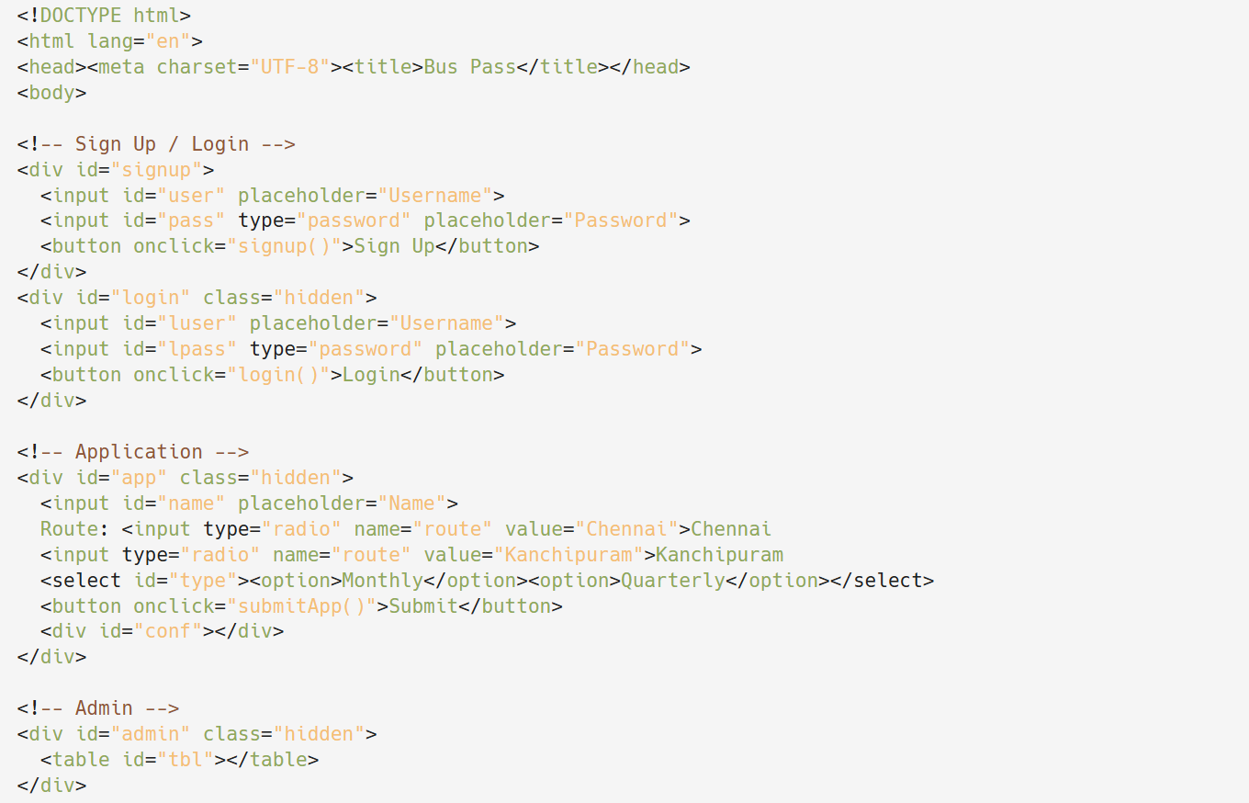

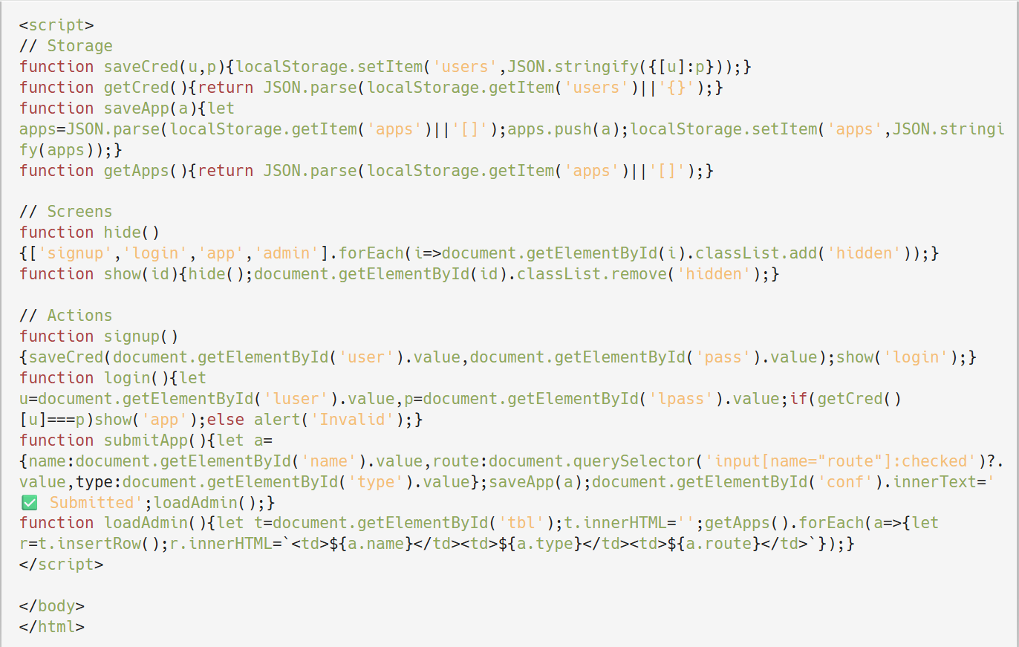

**OUTPUT**

**Fig 1: Front Page of website**

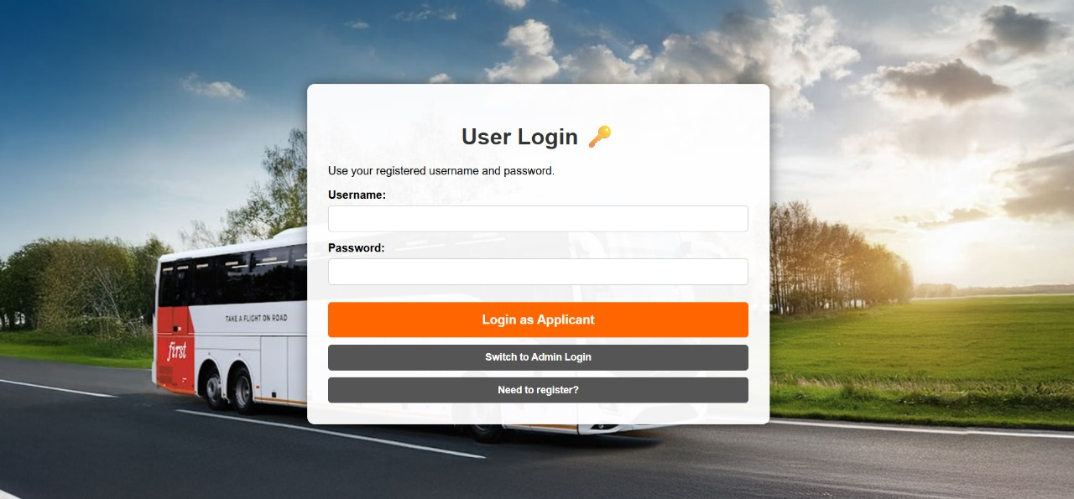

**Module 1**

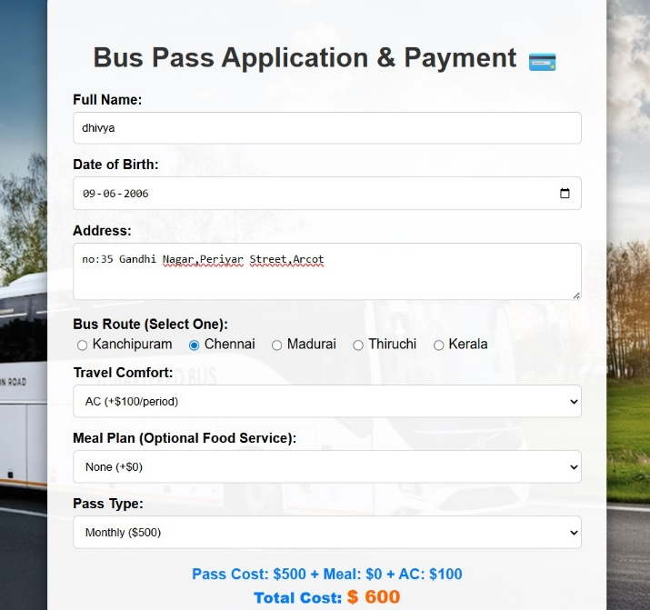 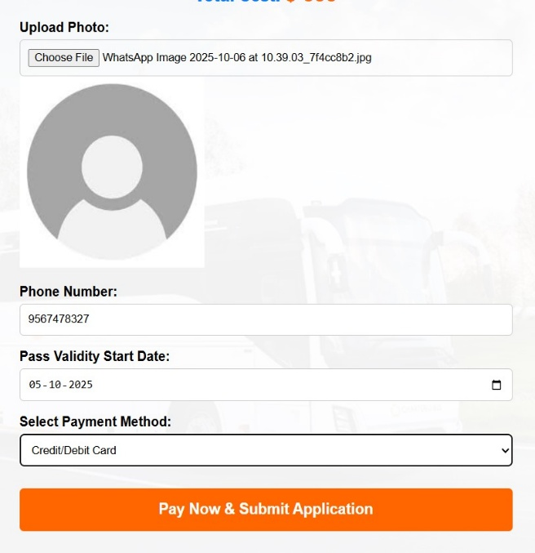

**Fig:2 Fig:3**

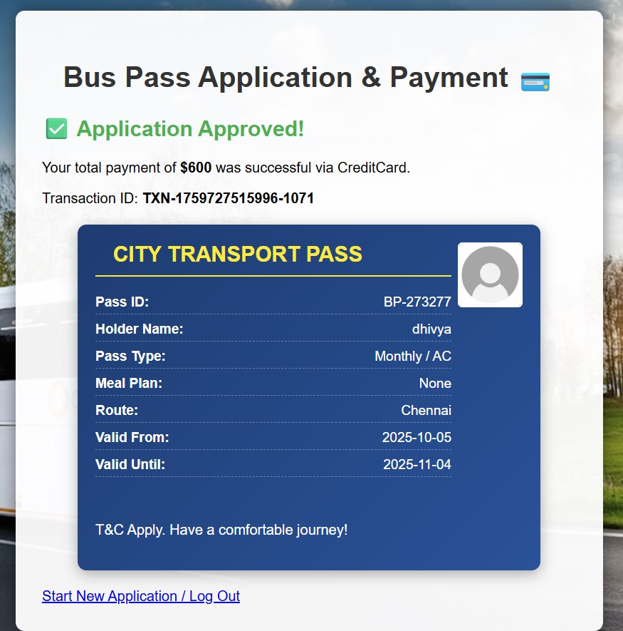

**Fig : 4**

**Module 2**

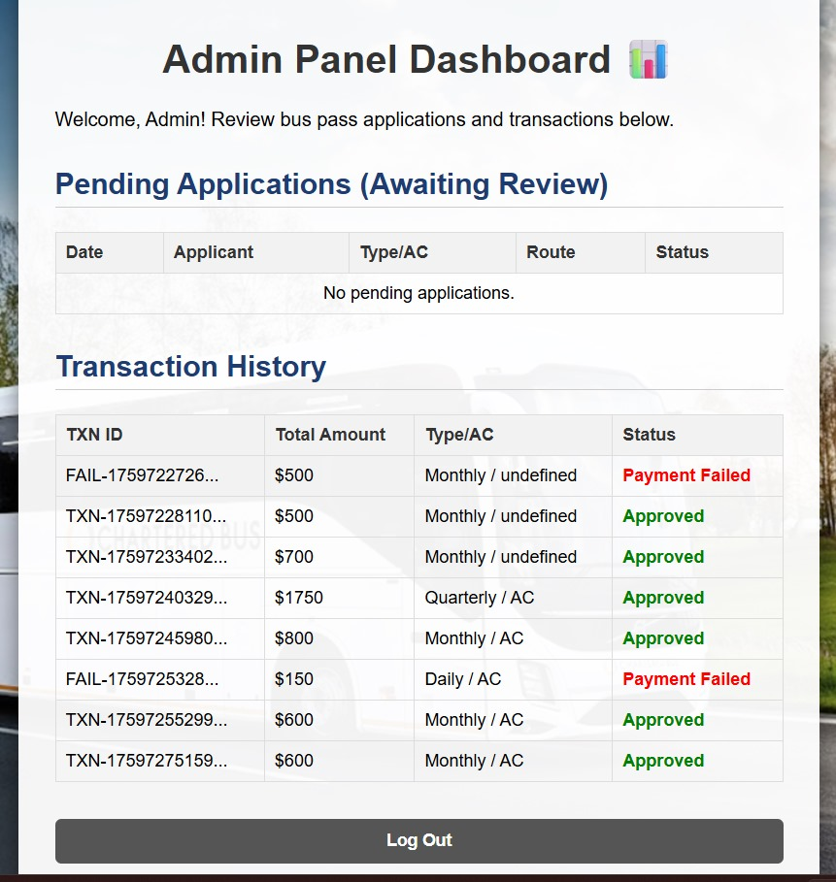

**Fig:5**